Homework # 5 – Runs Test Tutorial on SPSS for Windows

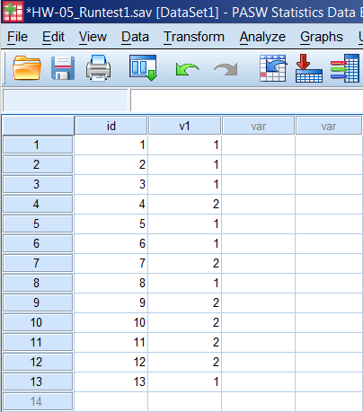
Homework-05 Manual calculation:

Given values: 1 1 1 2 1 1 2 1 2 2 2 2 1

No. of 1s = 7 = m; no. of 2s = 6 = n; No. of runs = 7 = r

From the Run Test table we find that
the critical value for (7, 6) = (3, 12)

Since the number of r = 7 lies between this range (3, 12), this means that fails to reject the null hypothesis.

Thus, the order of the 1s and 2s is random.
- Not significant

Hypotheses:
- The alternative hypothesis H_{a}, is the order of the 1s and 2s is not random.
- The null hypothesis H_{o,} is the order of the 1s and 2s is random.

SPSS Output:

NPar Tests
Descriptive Statistics
 | N | Mean |  | Std. Deviation |  | Minimum | Maximum
v1 | 13 | 1.46 |  | .519 |  | 1 | 2
Runs Test
 |  |  | v1
Test Valueª |  |  | 1^{b}  The run test results indicate that the order of the 1s and 2s is random as the test result is non-significant (N = 13, z = 0, p>.01).  - If I were the researcher I would conclude that since the z-score is less than the critical z-score at .01, I would accept the null and say that the order probably random.  - An experiment of tossing a coin was conducted 13 times and the sequence of turning a Head or a Tail was recorded. A RUNS test for randomness of order of Heads and Tails was performed using SPSS. The results showed that the order of the outcomes of Head and Tails was random.
Cases < Test Value |  |  | 0
Cases >= Test Value |  |  | 13
Total Cases |  |  | 13
Number of Runs |  |  | 1^{c}
a. Median
b. All values are greater than or less than the cutoff. Runs Test cannot be performed.
c. Only one run occurs. Runs Test cannot be performed.

Runs Test 2
 | v1
Test Valueª | 1.50
Total Cases | 13
Number of Runs | 7
Z | .000
Asymp. Sig. (2-tailed) | 1.000
a. User-specified.

